**Procedures**

**Tracking Defects and Enhancements**

This will be tracked using the team's Google Code, issue tracking website http://code.google.com/p/info637-team-dragon/issues/list.

**Change Request Form**

A change request form will be the means by which larger defects and enhancements are documented.  Once the first baseline has been created, newer development will be considered as an enhancement.  
  
The Configuration Change Request (CCR) form can be found on Page 325 of Introduction to the Team Software Process.

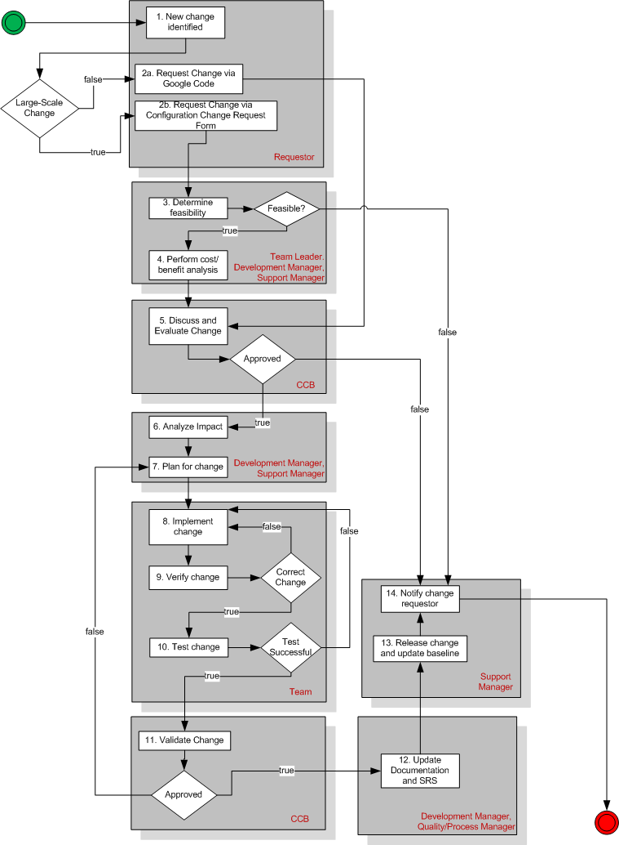

**The Change Control Process**

The flow diagram above describes the typical change control process the team will utilize.  The initial step of determining change size is to be determined over time, as this is difficult to quantify during project start.  The table below describes each step of the process.

**Description of Change Control Process**

|  |  |
| --- | --- |
| **Step** | **Description** |
| 1 | Identify issue, this can be with either documents or software |
| 2a | If a small change is requested, the requestor will use Google Code to submit the change |
| 2b | If the change is large, the requestor will use a Configuration Change Request (CCR) form |
| 3 | The Team Leader, Development Manager, and Support Manager determine if this change is able to be performed.  Possible reasons for rejection include:  ·         Non-discrepant (does not make sense and is not complete)  ·         Procedural Error (wrong process followed to create problem)  ·         System Fix Already Available (change is in process of completion)  ·         Duplicate  ·         Too Costly  ·         One Time Occurrence (cannot reproduce problem) |
| 4 | If the change is not rejected after initial review, a cost/benefit analysis is performed to determine if implementation and research is financially plausible. |
| 5 | Information gathered from steps 3 and 4 are passed to the Configuration Control Board (CCB) to perform their own deliberating.  A final decision is made.  If the change is rejected, it is sent back to the request with the reason(s) for rejection. |
| 6 | Change request has been approved; the Development Manager and Support Manager will determine implementation process. |
| 7 | Time allotment for change occurs (usually done with the Support Manager and/or Team Leader). |
| 8 | Implementation for change begins |
| 9 | The change is validated once the change is implemented |
| 10 | If the change is validated, testing is performed |
| 11 | Change is verified for completeness and functionality.  If unapproved steps 7-11 occur until completeness is achieved |
| 12 | Documentation and requirements are updated (if necessary) by the Quality/Process Manager and/or Development Manager |
| 13 | Change is released and the system baseline is updated by the Support Manager |
| 14 | Requestor is notified that change is successful. |